Worksheet: Creating mean plots with error bars in EXCEL
Example: Average time spent in A&E by season
Data
Data can be arranged in spreadsheet either by row, where each row represents the different variables:
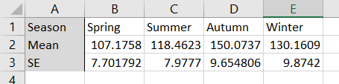

Or by column, where each column represents the different variables:
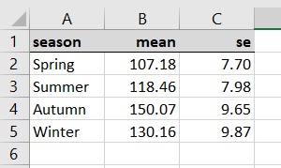

Constructing the chart
- Highlight the X and Y data. This is easiest to do if they are next to each other. If not you can highlight the first variable and then press and hold the CTRL key whilst highlighting the second variable.
- Go to INSERT > 2-D LINE > LINE WITH MARKERS
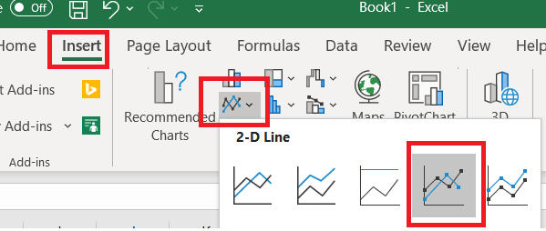
- This will produce the following graph. You now need to edit it to add on the error bars.

- Click anywhere on the plot to open up the CHART DESIGN menu.
ADD CHART ELEMENT > ERROR BARS > MORE ERROR BARS OPTIONS

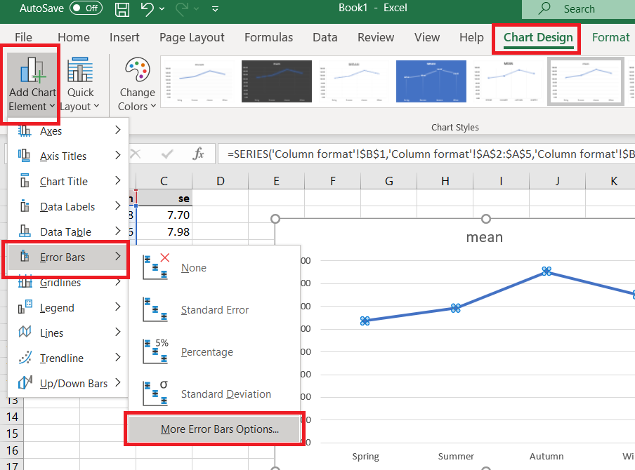

- This will add error bars to your plot, but they will not be based on the standard error values that you have in the spreadsheet. To update the chart with the correct error bar data, click on one of the error bars (it doesn’t matter which one) and this will open up the right-hand side editing menu for the error bars. Click on the right-most icon (1) and at the bottom of the menu select CUSTOM (2). Then in the CUSTOM ERROR BARS box that opens up click in the POSTIVE ERROR VALUE box selecting the value that is there, then highlight the data range in the spreadsheet so that it is copied into the box (3). Repeat this for the NEGATIVE ERROR VALUE box and click OK

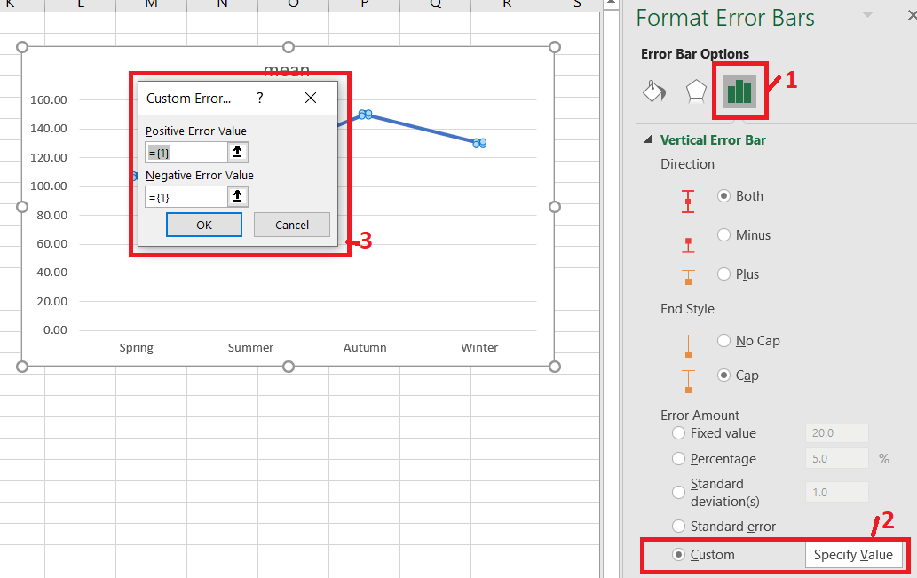

- You can then edit the chart to add a title and axis labels, tick marks etc, and remove the line if you decide that you don’t want it. In this plot where we are looking at the average waiting time in A&E by season of the year, you might want to keep the line, but in general if the groups were completely separate, the line would not be helpfu to understanding. Here’s the final chart with the line removed:

- You can create charts with more than one series of data using a similar methodology. Ensure that when you first draw the chart you have only the X and Y data for all the series that you want to draw highlighted, but not the error bar data. As with the example illustrated here, you add in each of the error bars later.
- Note that as you select the upper and lower limits separately, this also allows you to draw positive and negative bars that are different sizes

