Worksheet: Basic summary measures in EXCEL
Example: People with diabetes randomised to either an educational health intervention or care as usual. Key outcomes include quality of life and HbA1c (a measure of how well the diabetes is controlled). Measurements were made at baseline (before the intervention), and 12 months later
Basic summary measures
It is straight forward to produce basic summary statistics for your data using the Data Analysis ToolPak: Select Data > Data Analysis > Descriptive Statistics from the list to open the dialogue box below
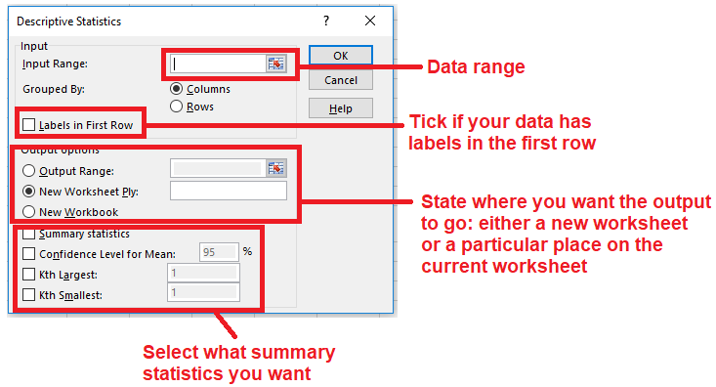
- The input range is the cells containing the data set that you want Excel to provide statistics for
- Choose a blank cell for the output or select ‘New Worksheet’ if preferred. The output is shown below.
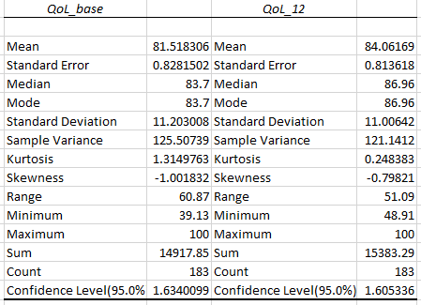
All of these measures can also be calculated by Excel Formulae, The corresponding formulae are shown below alongside the standard Descriptive Statistics output.

 | QoL_base | QoL_base (by formula)
Mean | 81.518306010929 | =AVERAGE(F2:F184)
Standard Error | 0.8281502 | =STDEV.S(F2:F184)/SQRT(COUNT(F2:F184))
Median | 83.7 | =MEDIAN(F2:F184)
Mode | 83.7 | =MODE(F2:F184)
Standard Deviation | 11.203008 | =STDEV.S(F2:F184)
Sample Variance | 125.50739 | =(STDEV.S(F2:F184))^2
Kurtosis | 1.3149763 | =KURT(F2:F184)
Skewness | -1.001832 | =SKEW(F2:F184)
Range | 60.87 | =MAX(F2:F184)-MIN(F2:F184)
Minimum | 39.13 | =MIN(F2:F184)
Maximum | 100 | =MAX(F2:F184)
Sum | 14917.85 | =SUM(F2:F184)
Count | 183 | =COUNTA(F2:F184)

Using pivot tables to calculate summary tables

Example 1: To create a summary of Average Quality of Life Rating for the control and Intervention groups at Baseline and after 12 months

Click anywhere within your data table and select the ‘Insert Pivot Table’ icon from the Insert tab. The Table range should auto-fill, you just need to choose where to place the pivot table

This will create an empty pivot table and open the Pivot Table Field list.
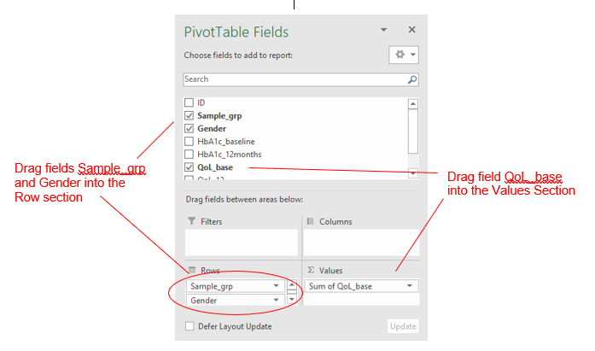

The data will be shown by default as a SUM of values. To change the values from SUM to AVERAGE, right click on any value and select ‘Value Field Settings’ then select Average from the list.

The resulting pivot table will look like this:
