PLEASANT TRIAL – SUPPLEMENTARY INFORMATION

Data Management Process – allocation of medical contacts and follow up data

Overview of methods for allocation of data to scheduled/unscheduled contacts
A scheduled contact was defined as any contact that is part of the planned care for the patient, for example an asthma review; a medical review; repeat prescription or immunisation. An unscheduled contact was defined as any contact not part of their care plan that is either patient initiated or as a result of illness.
To ensure the allocation of scheduled and unscheduled contacts was robust a GP adjudication panel consisting of 3 independent GPs attended meetings to review the data blind to treatment. The GP adjudication panel reviewed the unique terms (17% of the unique terms were reviewed which accounted for 90% of the data. During these meetings the GP adjudication panel devised the assumptions (i.e. rules) used to allocate to scheduled, unscheduled or not applicable (irrelevant) contacts. These assumptions were documented (see Appendix 3) and approved by the GP adjudication panel.
All types of ‘consultation’ are recorded within the data that CPRD provides; each consultation was considered a medical contact. Not all consultations are considered relevant to the study. One ‘consultation’ in the consultation table was considered one contact. All consultation data supplied are taken into account for the study not just those that are asthma related. Only consultations that happened on or after 1st August were included.
Assumptions used to code records as scheduled, unscheduled or not applicable were based on a GP adjudication panel review of the clinical, immunisation, therapy, referral, test and consultation data.
The ‘medcode description’ from the clinical data was used first as it was felt that this table gave most description about the reason for the consultation. If contact type could not be determined by the ‘medcode description’ then clinical consultation was referenced.
Following GP adjudication panel review of the medcode descriptions and clinical consultation types, where over 90% of the data was reviewed (17% of the unique terms), clinical records were identified to be marked as scheduled (these include asthma annual review terms and other obvious types of planned appointments); unscheduled (e.g. examinations, emergency appointments); not applicable (e.g. DNA) or unknown.
The clinical data contains more than one record per consultation and the same consultation ID can have more than one clinical contact type. For these clinical records, we assumed that unscheduled takes precedence (i.e. they are likely to have come in for an unscheduled visit but had a scheduled ‘type’ of procedure at the same time).
Consultation data marked as unknown based on the clinical data as well as consultation data that did not link to clinical data are coded based on immunisation, therapy, referral, test and consultation data. If at least one match was found in the immunisation record they were coded as scheduled. If at least one match was found with therapy (medication) data they were coded unscheduled. If they matched with the test data as part of the routine asthma review then they were coded as scheduled; if they matched with test data of peak expiratory flow rate (PEFR)/ peak flow rate (PFR) they were coded as unknown; otherwise a match with test data was coded as unscheduled.
Finally contacts were coded on the consultation type in the consultation table; where consultation types of follow-up / routine visits, repeat issue and medicine management were coded as scheduled; consultation types which indicate an emergency visit were coded as unscheduled; administrative type consultation types were coded as not applicable and those which were unclear, e.g. Clinic, Surgery consultation and Other were coded as unscheduled because of the likelihood that most scheduled consultation types would be clearly recorded. Details of how this has been applied and other assumptions to propose the allocation of medical contacts as ‘scheduled’ and ‘unscheduled’ are described in this document.

Data received from CPRD
Initial test data set received 10th May 2013
First baseline data set received 19th December 2013
2nd baseline data set received 3rd February 2014
3rd baseline data set received 13th July 2014
Baseline and follow-up data set received 19th January 2015

CPRD data
Data from the Consultation, Clinical, Immunisation, Test, Referral and Therapy tables from CPRD Gold Data Dictionary were used.

Overview
Figure 1 shows a very broad overview of how the data has been processed and the number of records. Full details of assumptions are in the following sections.

Figure 1: Decision tree showing an overview of how medical contacts have been allocated
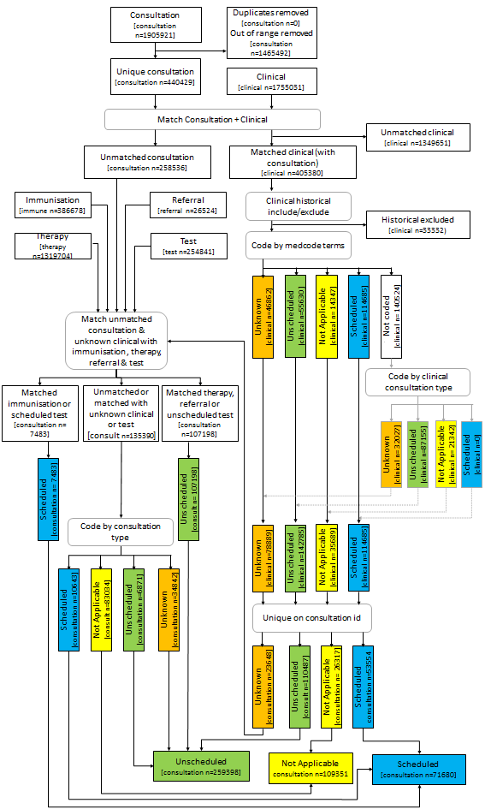

General assumptions
One ‘consultation’ (based on the combination of patient ID, practice ID and consultation ID) in the consultation table is considered one contact.

All consultations data supplied are taken into account for the study not just those that are asthma related.

Only consultations that happened on or after 01/08/2012 are included.

Assumptions used to code records as scheduled or unscheduled (contact type) are based on clinical, immunisation, therapy, referral, test and consultation data.

Records with unmatched event dates
Each consultation record is supplied with an event date; this event date does not always match the event date recorded for that consultation within the other tables. This is most likely due to information entered into the database historically. Those contacts within the clinical table were included if they are relevant and unlikely to be duplicated (see “Inclusion of ‘unmatched / historical’ data” section for more details). All immunisation, therapy, referral and test records that did not match the event date supplied in the consultation data were excluded.

Clinical data
Clinical data is linked to consultation data, all matched records are included.

Inclusion of ‘unmatched / historical’ data
If the event date does not match but the clinical event date is within the dates of interest (i.e. from 1st August 2012) then those records which are both relevant and unlikely to be duplicated are included. The decision on which records to include was made by the GP adjudication panel after reviewing the most common unique terms (10% of the terms which covered 88% of the data). The most common 10 terms and the decision as to whether to include is shown in Table 1 for information; rules based on this review were used to decide whether or not to include the 12% of data not reviewed, e.g. “if it contains seen it is relevant and unlikely to be duplicated”.

Table 1: Inclusion of ‘unmatched / historical’ data
Medcode desc | Records | Flag
Seen in paediatric clinic | 5214 | Relevant and unlikely to be duplicated
Seen in hospital casualty | 4863 | Relevant and unlikely to be duplicated
Letter received | 2901 | Irrelevant
Letter encounter | 2654 | Irrelevant
Administration | 2167 | Irrelevant
Seen in orthopaedic clinic | 1699 | Relevant and unlikely to be duplicated
Letter from consultant | 1587 | Likely to be duplicated
Letter from specialist | 1488 | Likely to be duplicated
Discharge summary | 1479 | Likely to be duplicated
Asthma | 1398 | Likely to be duplicated

Summary of coding using clinical data
The records included are used to determine scheduled or unscheduled based on ‘medcode description’ initially; the clinical data references Pegasus medical data using the field ‘medcode’ to get ‘medcode description’. If contact types cannot be determined by ‘medcode description’ then clinical consultation type ‘constype’ (consultation type) is referenced.

Following GP adjudication panel review of the medcode descriptions; where over 90% of the data was reviewed (17% of the unique terms) clinical records to be marked as scheduled; unscheduled; not applicable or unknown were identified based on terms (see tables Table 2-5 for examples: full details are available on request if required). Based on this review rules to apply to the data were also determined (see Table 6). Finally, decisions on how to code the remaining records based on the clinical consultation type were made (see Table 7).

Table 2: Clinical Records: Scheduled
Medcode_desc
Administration of medication under patient group direction
Administration of medication under patient specific directn
Antimalarial drug prophylaxis
asthma annual review
Asthma causes daytime symptoms 1 to 2 times per month
Asthma causes daytime symptoms 1 to 2 times per week
Asthma causes daytime symptoms most days
Asthma causes night symptoms 1 to 2 times per month
Asthma causes symptoms most nights
Asthma causing night waking
Asthma control questionnaire

Table 3: Clinical Records: Unscheduled
Medcode_Desc
Abdomen examined - NAD
Abdominal examination - NAD
Breast examination
CVS examination
CVS examined - NAD
Ear examination - normal
emergency appointment
Exam. of cardiovascular system
Exam. of digestive system
Examination of abdomen

Table 4: Clinical Records: Not Applicable
Medcode_Desc
[V]Healthy person accompanying sick person
Advice to GP to change patient medication
Did not attend - no reason
Discharge from hospital
Discharged from accident and emergency
Discharged from inpatient care
Drug not collected - no reason
Employment milestones
Failed encounter
Failed encounter - message left on answer machine

Table 5: Clinical Records: Unknown
Medcode_Desc
[V]Issue of repeat prescription
Advice
Asthma
Asthma medication review
Asthma monitoring due
Asthma NOS
Bronchial asthma
Change in asthma management plan
Clinical management plan agreed
Family history

Table 6: Medcode description rules coding
Letter rule | If contains 'letter' then scheduled unless it contains 'referral', in that case it's not applicable
Pain/inflamed/sore rule | If contains 'pain', 'inflamed' or 'sore' then it's unscheduled
Asthma trigger rule | If contains 'Asthma trigger' then scheduled unless it contains 'infection' then it's unscheduled
Immunisation/vaccination rule | If does not contain 'letter' and contains 'immunisation', 'immunisats', 'imm', 'vacc' or 'vaccination' then 'Scheduled' unless it contains 'flu', 'Influenza', 'advice', 'not consent', 'declined' or 'requires' in that case it's 'unknown'
Exam/examination rule | If contains 'exam' or 'examination' then unscheduled, unless it contains 'chest', 'respiratory', 'lung', 'breath', 'foot' or 'eye' then it's scheduled
Asthma management plan rule | If contains 'Asthma management plan' then scheduled unless it also contains 'change' or 'step up', in that case it's unknown
Referral rule | If contains 'Referral' then not applicable unless it contains 'a and e', 'accident and emergency' or 'admission', in that case it's unscheduled
Blank rule | If blank then it's unscheduled
DNA rule | If it contains 'Did not attend' or 'DNA' it's not applicable
Failed encounter rule | If it contains failed encounter it's not applicable
lloyd george rule | If it contains lloyd george it's not applicable
Seen rule | If it contains ‘seen’ it's scheduled, unless it contains accident, emergency, out of hours, GP, A&E, A & E, rota, primary care centre, patient call, triage, co -op, coop, co op, walk in, ooh, triage, injury, on call, home visit, urgent, surgery, doctor in which case it's unscheduled
Out of hours rule | If it contains out of hours then it's unscheduled
Emergency rule | If it contains emergency then it's unscheduled
Discharge report | If it contains discharge report then it's unscheduled

Table 7: Clinical consultation type coding
Clinical consultation type | Code as
Administration | Not applicable
Symptom | Unscheduled
Diagnosis | Unscheduled
Intervention | Unscheduled
Management | Unscheduled
Presenting complaint | Unscheduled
Examination | Unknown

Conflicting clinical contact types
Clinical data contains more than one record per consultation. In some cases the same consultation ID can have more than one clinical contact type. For these clinical records, we assume that unscheduled takes precedence (i.e. they are likely to have come in for an unscheduled visit but had a scheduled ‘type’ of procedure at the same time) over all other contact types, scheduled take precedence over not applicable and unknown and unknown takes precedence over not applicable.

Clinical to consultation
The code assigned in accordance with clinical contact type as described above is linked to the consultation data.
Consultation data marked as ‘unknown’ based on the clinical data as well as consultation data that did not link to clinical data are coded based on immunisation, therapy, referral, test and consultation data as described in the following sections.

Immunisation data
Uncoded consultation data are matched against immunisation data; if at least one match is found in the immunisation record then these are marked as ‘Scheduled’.

Therapy
Those that do not match with immunisation data are linked to medication data. If at least one match is found they are marked as ‘unscheduled’.

Referral
Those that do not match with immunisation or therapy data are linked to referral data. If at least one match is found they are marked as ‘unscheduled’.

Test
Those that are still uncoded are linked to test. If linked to test it is coded as either ‘scheduled’, ‘unknown’ or ‘unscheduled’ based on a review of the data. In general, if the test is part of the routine asthma review then it is coded as ‘scheduled’; if it’s PEFR/PFR then it is coded as ‘unknown’. Otherwise it is coded as ‘unscheduled’ (full details are available on request).

Where a consultation links to more than one record the same rules of precedence apply as outlined in the “Conflicting clinical contact types” section.

Consultation data
For consultation data which is still ‘unknown’, ‘unlinked’ and therefore uncoded, consultation type is used to determine scheduled, unscheduled or N/A. See Table 8 for a summary (full details are available on request). In this way all contacts will now be coded as either ‘scheduled’, ‘unscheduled’ or ‘not applicable’.

Table 8: Consultation type coding
Consultation type | Coded as
Follow-up/routine visit  Repeat issue  Community Clinic  Medicine Management | Scheduled
If the consultation is about out of hours visits, telephone call, acute visit, inpatient/hospital admission, accident and emergency attendance, triage, home/hotel visit, walk-in centre, co-op surgery or injury | Unscheduled
Clinic  Surgery consultation  Other | Unscheduled (it is assumed that most scheduled consultation types will be clearly recorded).
If the consultation type is ‘Data not entered’ or if they are about correspondence, reports, administration, nursing/residential home visits, test results or non-consultation data. | Not applicable

Emergency contacts
In addition to coding to scheduled, unscheduled and not applicable some consultation types from the consultation table were coded as emergency (see Table 9).

Table 9: Emergency contact codes
Code | Consultation Type | Relevant medical contact? | unscheduled / scheduled | Emergency
2 | Night visit, Deputising service | Yes | unscheduled | Yes
4 | Night visit, Local rota | Yes | unscheduled | Yes
6 | Night visit , practice | Yes | unscheduled | Yes
7 | Out of hours, Practice | Yes | unscheduled | Yes
8 | Out of hours, Non Practice | Yes | unscheduled | Yes
11 | Acute visit | Yes | unscheduled | Yes
18 | Emergency Consultation | Yes | unscheduled | Yes
20 | Casualty Attendance | Yes | unscheduled | Yes
23 | Hospital Admission | Yes | unscheduled | Yes
24 | Children's Home Visit | Yes | unscheduled | Yes
27 | Home Visit | Yes | unscheduled | Yes
28 | Hotel Visit | Yes | unscheduled | Yes
32 | Twilight Visit | Yes | unscheduled | Yes
34 | Walk-in Centre | Yes | unscheduled | Yes
37 | Co-op Home Visit | Yes | unscheduled | Yes
50 | Night Visit | Yes | unscheduled | Yes

